TUTORIAL

DesInventar Server 9

Version 9.2.11

March 2006.



Table of Contents

Table of Contents 3
Getting started 4
First step: Asking questions to DesInventar Server 5
Charting your results 7
Getting info about the composition of disasters in your database 7
How to identify trends in disaster occurrence. 8
Mapping your results 9

Getting started

This tutorial will help you getting the best out of DesInventar in a few steps, after which you will surely take off by yourself an explore the many features and the full potential of the system.

We assume here that you have properly installed your system following the Installation and Starter Guide, another easy tutorial that will get you up and running in no time.

First of all, you will need to start your server and open a DesInventar window. Just click on the corresponding options in the Start – All Programs - DesInventar menu options.

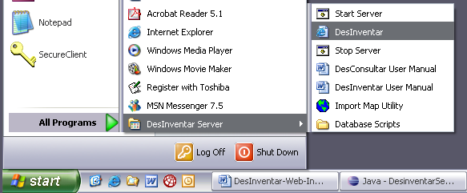

After you click on the entry you should see the DesInventar welcome screen:
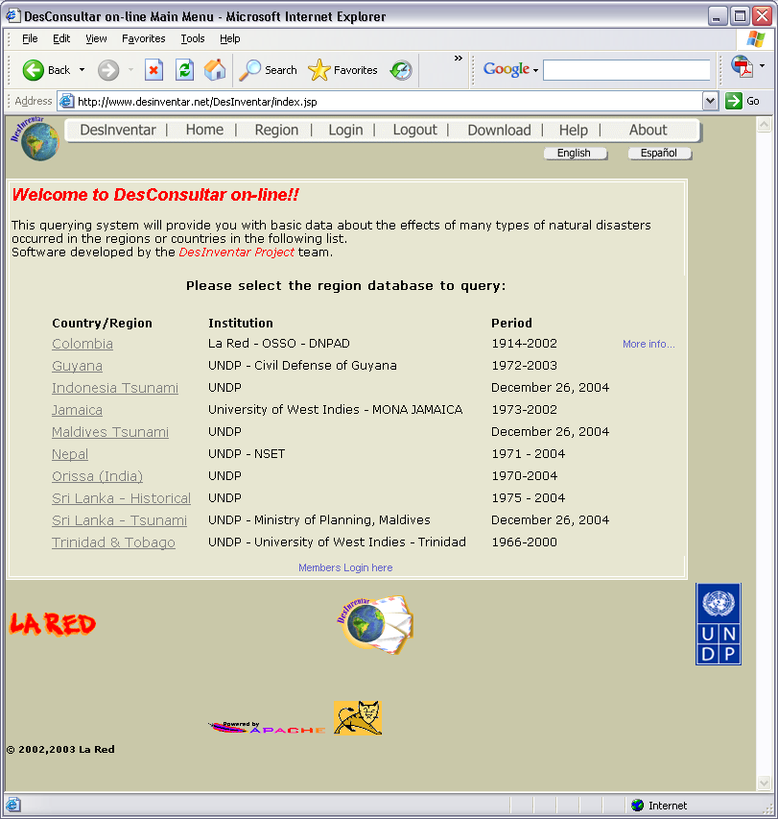

Just click on the name of the country (database) you want to work with. This tutorial works with the Sri Lanka database:

First step: Asking questions to DesInventar Server

The system always starts a session in the Query screen. This is the place where you will ‘ask’ DesInventar questions such as “Show me the all disasters that killed people in the District of Batticaloa (Eastern Province) during the 90’s”.

Lets do this: Just click on “Eastern Province”, then on “Batticaloa”. Now click on the checkbox besides “Deaths” and fill the years 1990 and 1999 in the ‘To’ and ‘From’ dates. Your screen should look like:
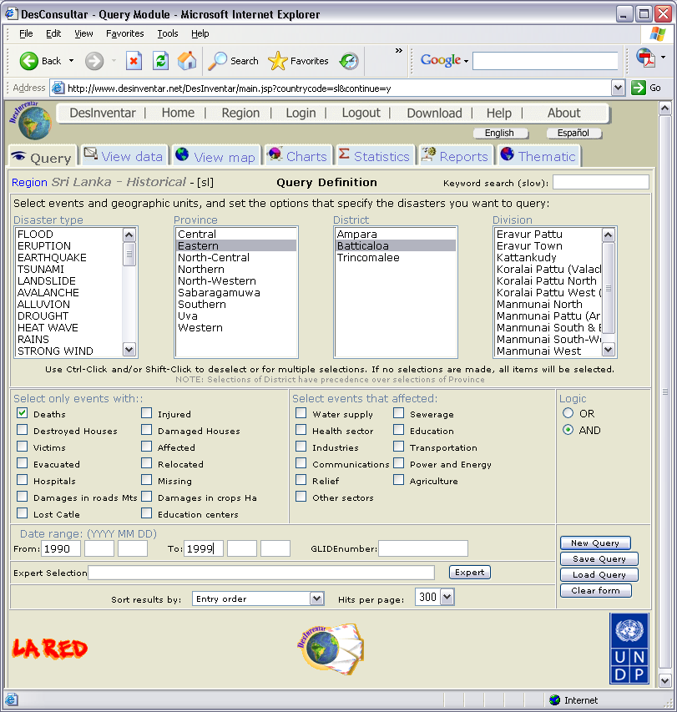
Five clicks, eight keys…

This is all you need!!! Five clicks and eight keys... it takes much longer to write the text form of the question!!!.

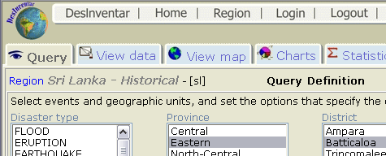
Now, just click on the View Data tab:
And voilá, there is the answer:

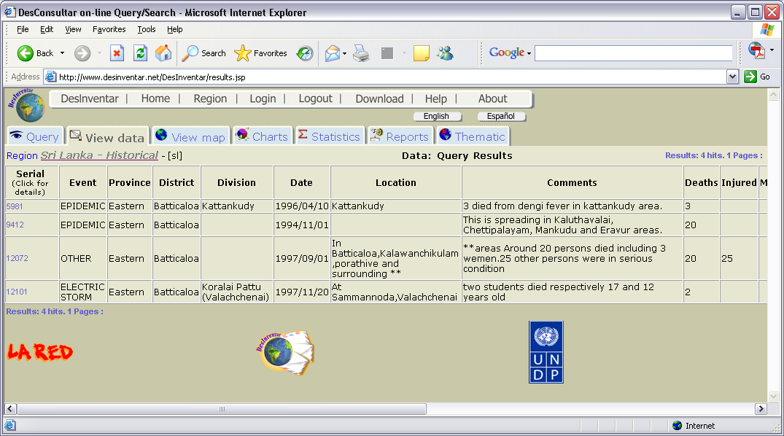

Now, we encourage you to explore a bit more of the Query Screen. You will NOT damage or erase any information using this tool.

A simple rule: The more selections you make, the less information you will get. The explanation for this is that as you click on more options you will put more and more restrictions in your question.

Here are some useful tips:

- You can select and deselect multiple items in the list boxes with clicks of your mouse in combination with the Ctrl (control) key.
- When you want to start over again, just click on ‘New Query’

Charting your results

Producing charts depicting the data you have selected in the query window is very easy. Please follow these two examples:

- Getting info about the composition of disasters in your database:
- How to identify trends in disaster occurrence.

Getting info about the composition of disasters in your database

Before starting this example please start over again. Click on the button “New Query” of the query screen. Now, just click on the Charts tab:

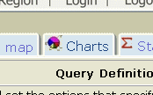

The Charts Definitions screen will come up:

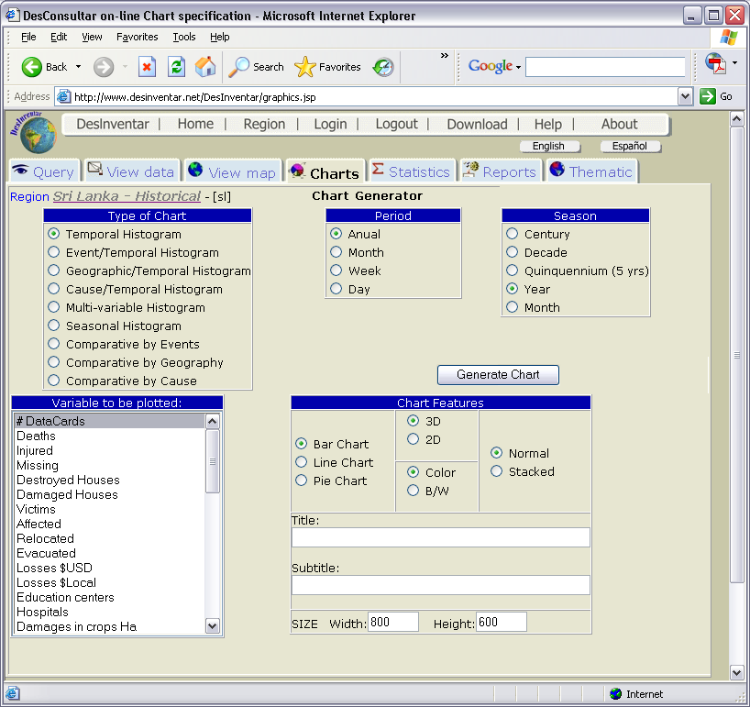

Click on the option “Comparative by Events” and the on the button “Generate Chart”
And that’s it, there is a great chart that will tell you what types of disasters are contained in the database:

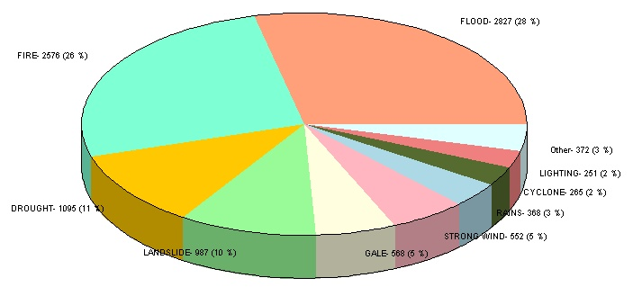

How to identify trends in disaster occurrence.
Click again in the query screen. Select the event “LANDSLIDE”. It should be highlighted. Click back in the Charts tab. Now click on “Temporal Histogram”, and see what comes back:
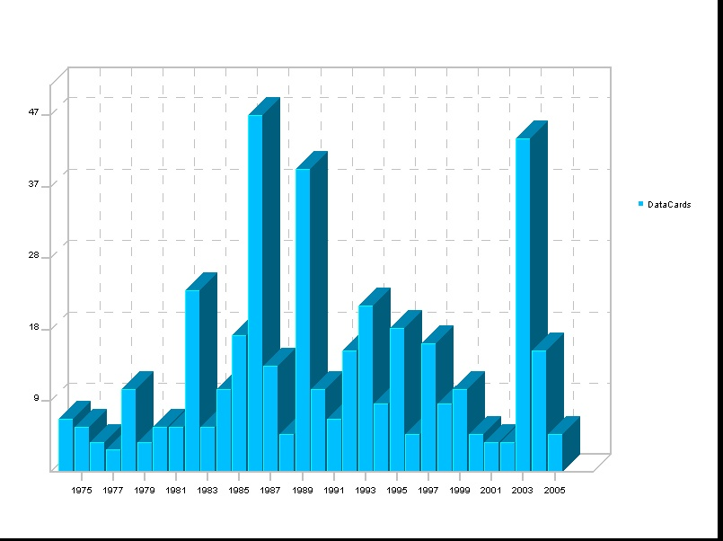
Could you draw some conclusions from this chart? – Now click on “Deaths” and generate the chart again. Interesting, isn’t it?

Mapping your results

DesInventar has two mapping components: one that provides information about the Administrative Boundaries that are used in the database, which also can be used as a selection tool, and a second component that will put information in these maps in the form of colors (or shades or disks) .

As you guessed the fist one is in the tab “View Map” and the second in “Thematic”. Lets see how “View Map” works. Imagine that you have been asked to produce a map of the southern provinces of Sri Lanka:

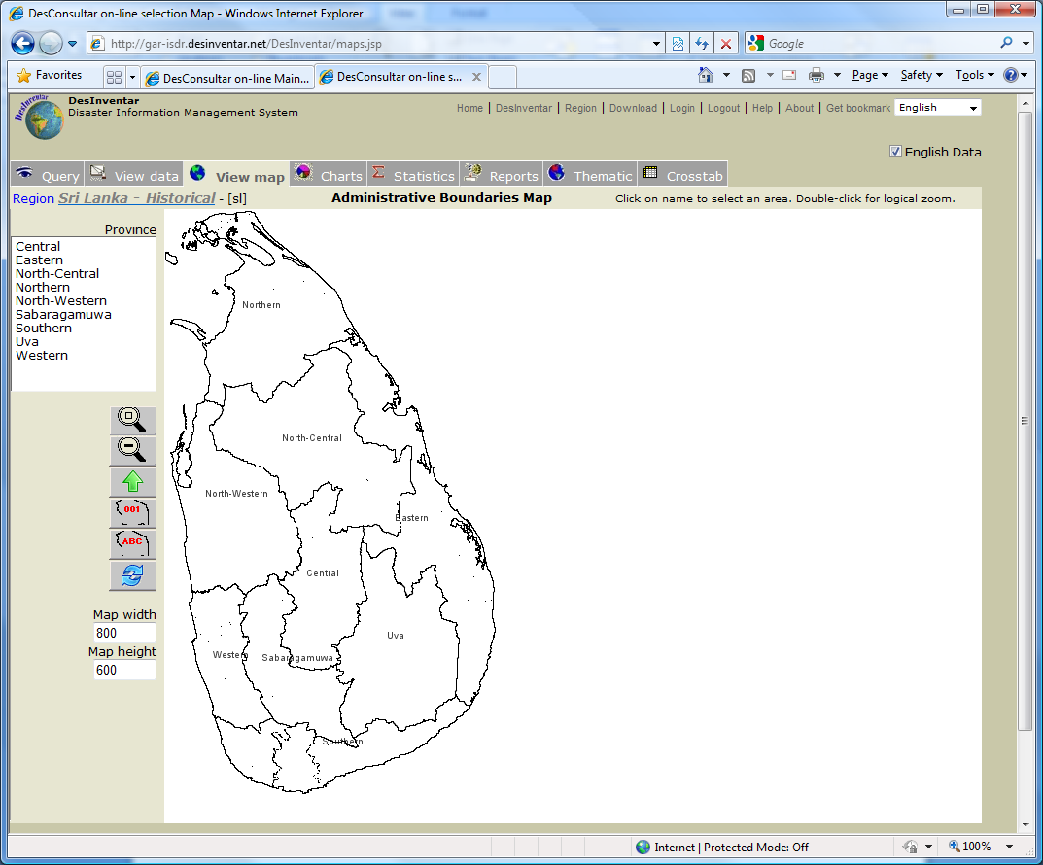

Now click on the names of the southern provinces: this, this, this and this… (Western, Sabaragamuwa, Southern and Uwa).

You will see that the provinces get selected because they will be filled with yellow. Please see the map next page. And if you go to ANY other tab, your selections will take effect:

- In the query window, these provinces will appear selected (highlighted).
- If you click on the “View Data” tab, only data from these provinces will be retrieved.
- Same applies for Charts, Reports and Thematic.
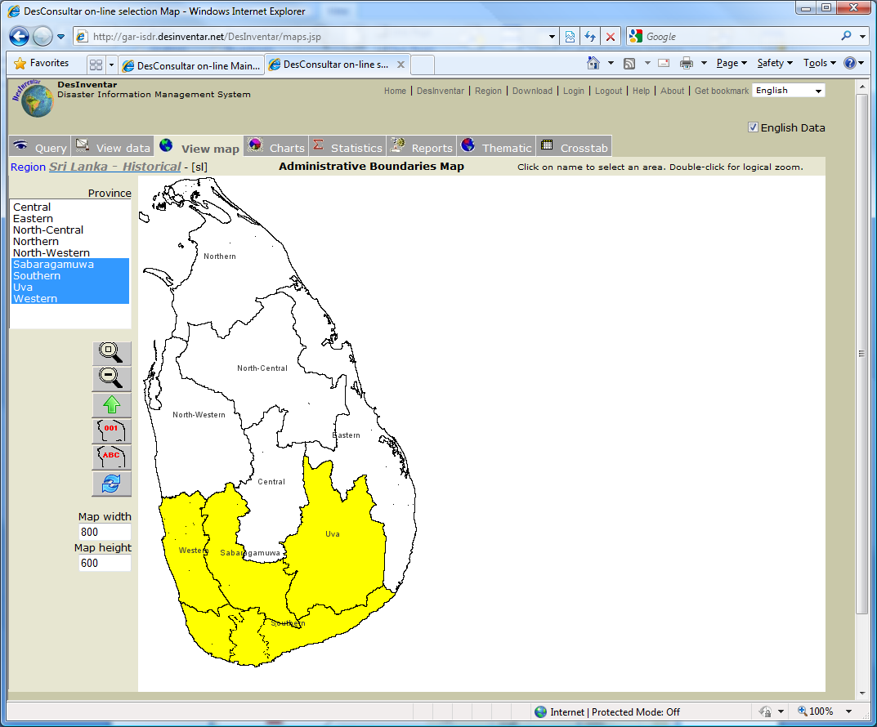

Now, lets jump to the thematic tab. Click on Iso-ranges and then in Generate Map…

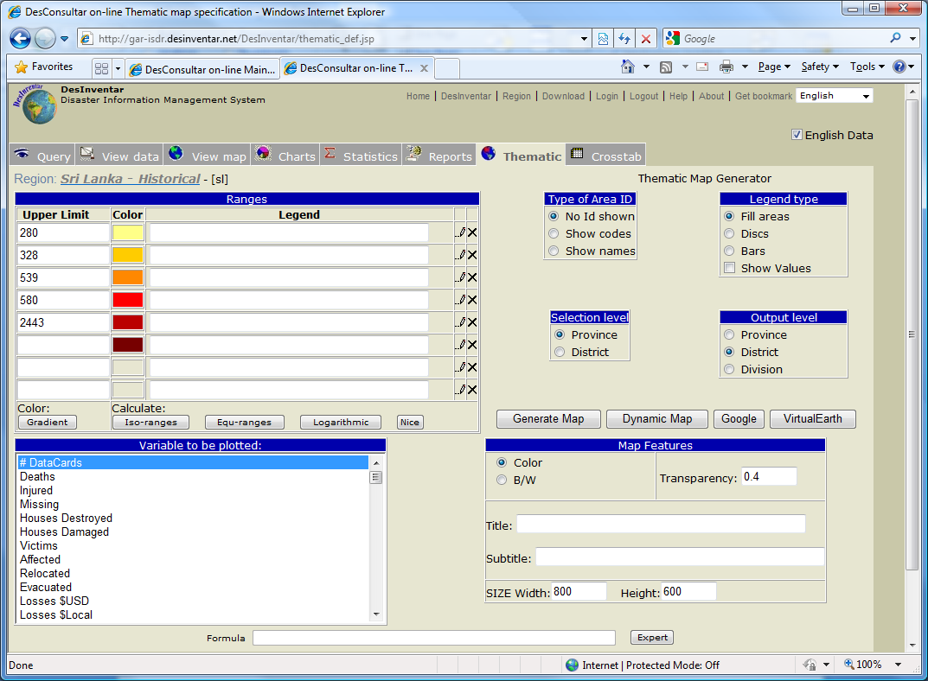

And this is the map you will get:

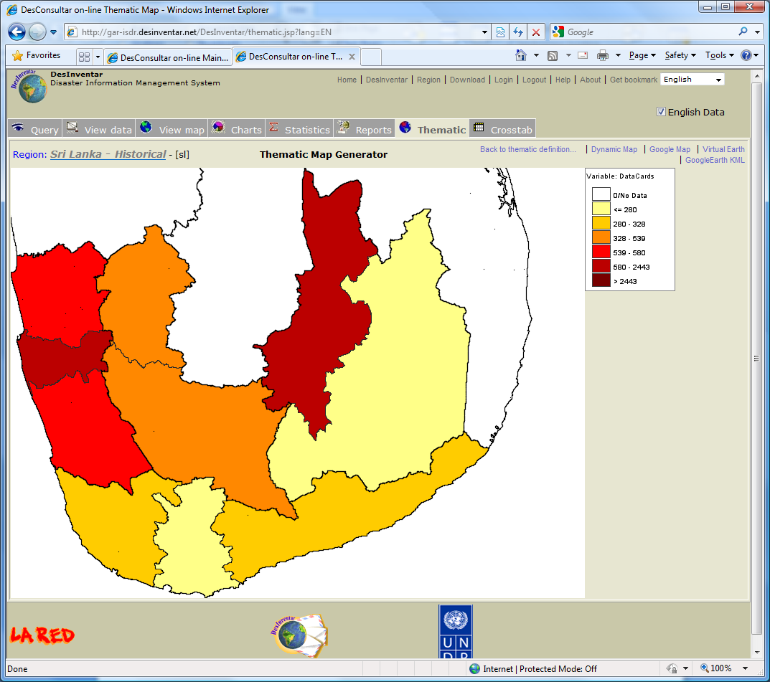

You may add a title to this map. The title should be something like “Number of Reports of Landslides in the Southern provinces of Sri Lanka” ….

Now do the same you did before with the histogram: click again in thematic and try mapping other variables. Select “Deaths”, “Housed Destroyed”, etc.

And try also producing a more detailed map. In the box marked “Output Level” select “Division” and generate the maps again. Cool….

These simple steps demonstrate how easy is to use the system and how powerful it is. Feel free to explore all the options, combinations of variables. You will find that results can be quite surprising (but logical, anyhow)

To get more detailed information please refer to the User manual and to the Preliminary Analysis Methodology. With these two documents and some practice you will be able to get full advantage of all the potential of your data (and of DesInventar!).

Good Luck!!!

