DesInventar
A tool for analyzing disaster trends

What is Des Inventar?

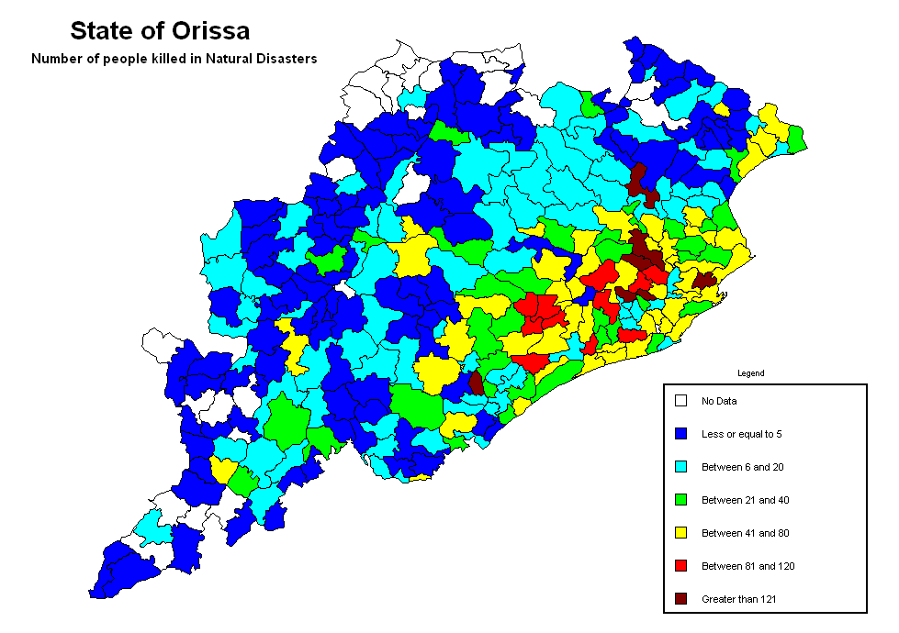
DesInventar is one of the very few existing proven methodologies and tools for building disaster databases. It permits the homogeneous capture, analysis and graphic representation of information on disaster occurrence and loss. It has been under continuous development and improvement since the inception of the project in late 1993, when the Network for Social Studies on Disaster Prevention in Latin America (LA RED) started to build systematic disaster inventory databases.

Where has it been used?

The DesInventar methodology has been extensively tested and used in Latin America and the Caribbean to build their disaster inventories. Many national emergency agencies in this region of the world have used and are using DesInventar as an input to their risk analysis, risk mitigation, the formulation of early warning systems, as well as a tool to follow up the success or evolution of their preparedness and mitigation plans along time, and even in many disaster situations as in the cases of El Niño disaster in Perú, hurricane Mitch in Honduras, and Armenia (Colombia) and El Salvador earthquakes.
Orissa: No. of people killed (by block) for all types of disasters

UNDP has undertaken the work in several countries of the English Caribbean (Jamaica, Trinidad, Guyana, Antigua) and in Asia disaster inventories have been built for the state of Orissa in India and for Kathmandu in Nepal. Efforts were also made to build disaster inventories for Sri Lanka and Maldives immediately after December 2004 tsunami.

What are the benefits of using DesInventar?
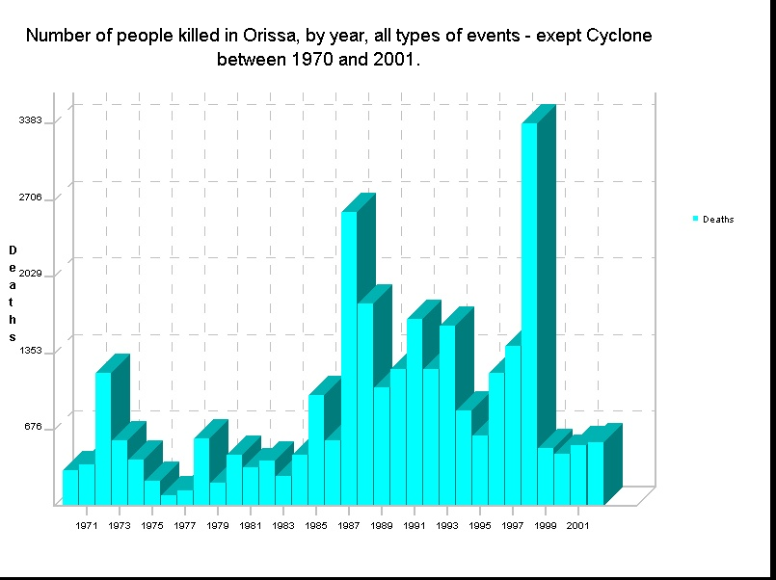
DesInventar is a tool that helps to analyze the disaster trends and their impacts in a systematic manner. With increased understanding of the disaster trends and their impacts, better prevention, mitigation and preparedness measures can be planned to reduce the impact of disasters on the communities.

How does it work?

The DesInventar methodology includes a software product with two main components. The DesInventar module is a relational and structural database through which the database is fed by filling in predefined fields (space and temporal data, types of events and causes, sources) and by both direct and indirect effects (over life, houses, infrastructure, economic sectors). The DesConsultar module allows access to the database by queries that may include relations among the diverse variables of effects, types of events, causes, sites, dates, etc. This module allows at the same time to represent those queries with tables, graphics and thematic maps.

How UN-ISDR/GAR and its partners can assist?
Based on the consultations with the tsunami affected countries, information management and capacity building for analyzing disaster trends was identified as one of the needs. The GAR in Geneva, through its projects for National Disaster Inventories and Capacity Building will initially extend support to Asian, African and the Caribbean to build these disaster inventories.

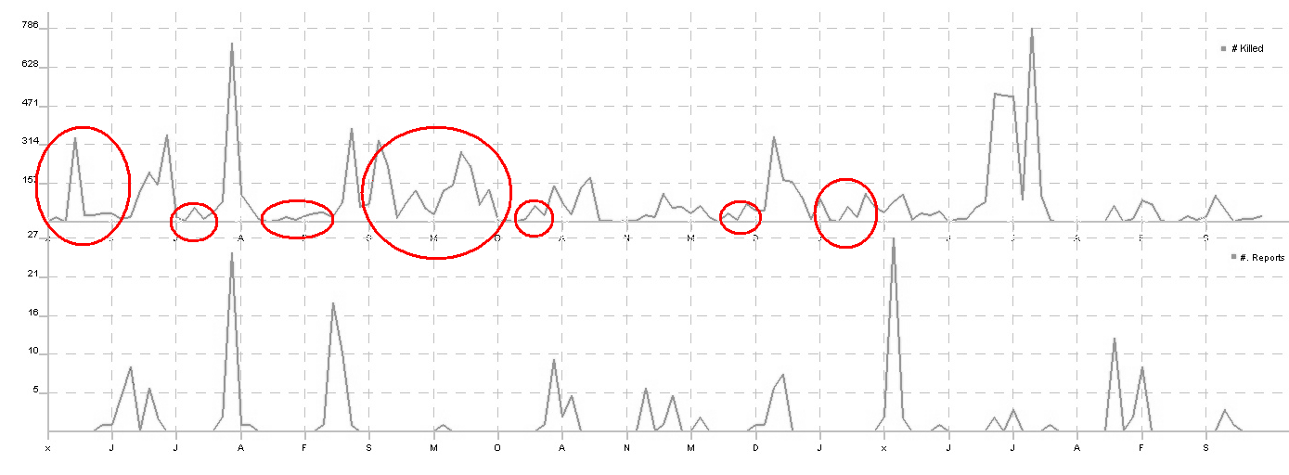
People killed by epidemic outbreaks, Orissa

Number of Flood reports

Number Flood reports and people killed by epidemics, 11 years, with apparently non-flood related epidemics.
This chart shows a cause effect pattern and how many epidemics episodes are not caused by floods

For more information, please contact:

Julio Serje
National Disaster Inventories network coordinator
Global Assessment Report GAR
UN-ISDR, Geneva

Tel: +41 22 917 8390
Email: serje@un.org

