

DesInventar Server 9

DesConsultar ®
Analysis and Query Module

USERS MANUAL
(Version 9.2.11)

Introduction

Welcome to the Analysis Module!

Background

The Network of Social Studies in Disaster Prevention in Latin America was incorporated in 1992, under Research and Internal Organization Statutes LA RED, COMECSO/ITDG, Lima, January 1993. One of the most important premises of DesInventar is as follows:

Population growth and urbanization processes, trends in land use, increasing impoverishment of significant segments of the population, use of inappropriate technological systems in the construction of houses and basic infrastructure, and inappropriate organization systems, amongst others, are factors that have increased the vulnerability of the population vis-a-vis the wide diversity of physical and natural events.

However, the lack of systematic, homogeneous, and compatible records of disaster typologies, understood as the effect of the occurrence of hazardous events on the vulnerability of communities, regions, countries or cities, on the one hand, and insistence on considering disasters only as effects of events of huge proportions and high impact, on the other, have hidden the thousands of small and medium scale disasters that occur every year in regions such as Latin America, the Caribbean, Asia and Africa.

Also, institutions and researchers of a number of countries are interested in this subject. But unfortunately, they use different tools to systematize the information on disasters -especially databases or physical files- designed on the basis of specific or sectorial criteria, and using different formats. Besides, there is a large volume of information pending compilation and systematization, specifically in graphic material.

This dispersed information must be compiled, compatibilized and analyzed. But it must also be geographically referenced, since disasters (affected communities and infrastructure) due to the effects of each type of event (threat) are regionalized variables.

Objectives

A common objective in regions and countries of Latin America and the Caribbean, Asia and Africa is to create capacity to analyze and represent hazards, vulnerabilities, and risks in terms of space and time, both retrospectively and prospectively; and the purpose of this capability is its application in risk management, whose activities go from mitigation to post-disaster attention and recovery.

Qualitative and quantitative evaluation of vulnerability and risk growth requires a sound base of documents and records including past, present and future (forecasted) disasters.

As a contribution to this common objective, LA RED began its project “Inventory of Disasters in Latin America” in late 1993. Its pilot stage comprised the following activities: a) discussion and definition of conceptual and methodological criteria for the analytical treatment of small, medium and large scale disasters; b) compilation of the information for years 1990 through 1994 in available sources, obtained from a sample of Latin American countries (Mexico, Guatemala, El Salvador, Costa Rica, Colombia, Ecuador, Peru and Argentina); and c) development of the systems tool required for this purpose.

DesInventar is then the synthesis of a process through which the research teams committed to LA RED proposed a framework under which the concepts and methodologies related to disasters were unified, and is also an instrument for the development of the objectives determined. The basic criteria guiding DesInventar are:

- all inventories must use the same variables to measure the effects, and a homogeneous and basic classification of events;
- the information compiled and processed must be entered in a scale of time and at a geo-referenced spatial level;
- the inventories must be analyzed (with computer tools, in this case) , which is a basic requirement in comparative research and to support decision-making processes related to mitigation actions and risk management as a whole.

DesInventar is also an instrument that allows to visualize, in space and time, the phenomena that have been registered, thanks to this additional instrument called Analysis Module or “DesConsultar”.

Definition of the Analysis Module “DesConsultar”

The Analysis Module is a querying instrument and a tool for the thematic and spatial-temporal analysis of the disasters homogeneously compiled by DesInventar. Its purpose is to facilitate the understanding of disasters as a reality ever present in the daily relationship of Society (and its technological development) and Nature. The facilities provided to make statistical analyses and spatial representations of queries are oriented to suggest some answers to the user, and a lot -we hope- of questions regarding the dimension of one of the most pressing modern conflicts: the disasters derived from the relationship among Society, Development and Environment.

To facilitate the compilation and treatment of the information, all inventories represented in the Analysis Module use the same variables to measure effects, and the classification of effects is also homogeneous and basic. The information entered in the system is geo-referenced according to the basic political-administrative division of each country. However, due to the evolution of the project, updated cartography for cantons and parishes is not available in the map of Ecuador; for districts and the map of Costa Rica, and for districts in some provinces in Peru. In the maps of the other countries, the second level of political-administrative units is available.

Starting the Analysis Module

Starting DesInventar is normally accomplished by starting a browser and typing the DesInventar system URL:

http://localhost:8081/DesInventar

The Welcome screen of the system will be shown:

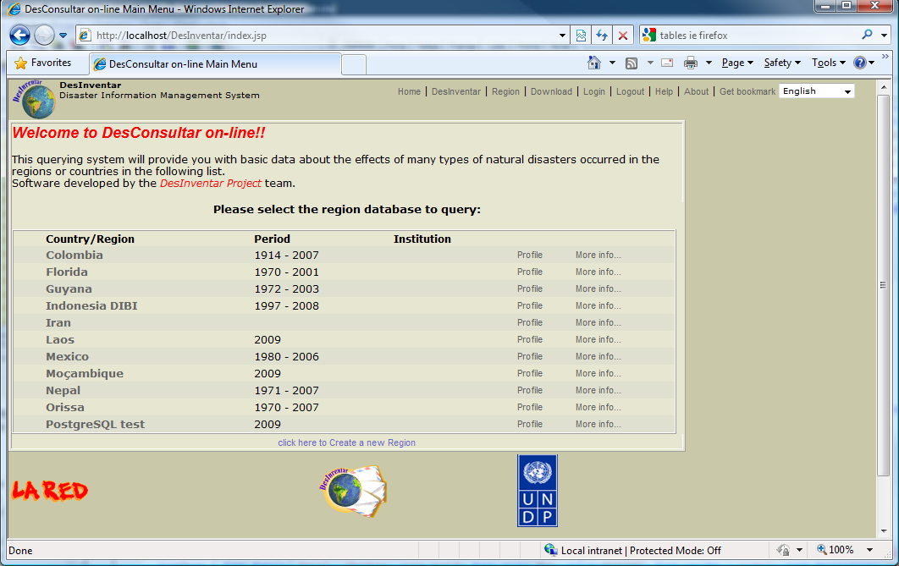
Graphic 1. DesConsultar Region Selection screen

Once your browser displays this screen you can select which region or country you want to query, just by clicking in the corresponding name (that happens to be a link).

Users may also hover the mouse over “More info”... to obtain additional information about the database (origin, number of records, major causes of losses, etc).

A profile link is also available so that a quick automated Preliminary Analysis is made on the data present in the system. These Preliminary Analysis contain composition charts (for #of records, mortality, housing sector and affected) and also trend charts and thematic maps for the same set of variables.

Description Of The System

The ultimate rationale of an information system goes beyond the initial and basic objective of achieving a methodical, homogeneous and systematic storage of information. Information is useless if there are no tools to retrieve, (query) and analyze.

Information retrieval processes must be selective, specific to the characteristics of the information. In the Analysis Module, retrieval is made based on thematic (type of event and causes), spatial component (geography) and time (dates) criteria.

The Query window, used to determine what data is to be retrieved is displayed. In this screen you will be able to tell the system what is the information you want to see in terms of the dimensions described. Please see detailed explanations of each of the options in this screen below.

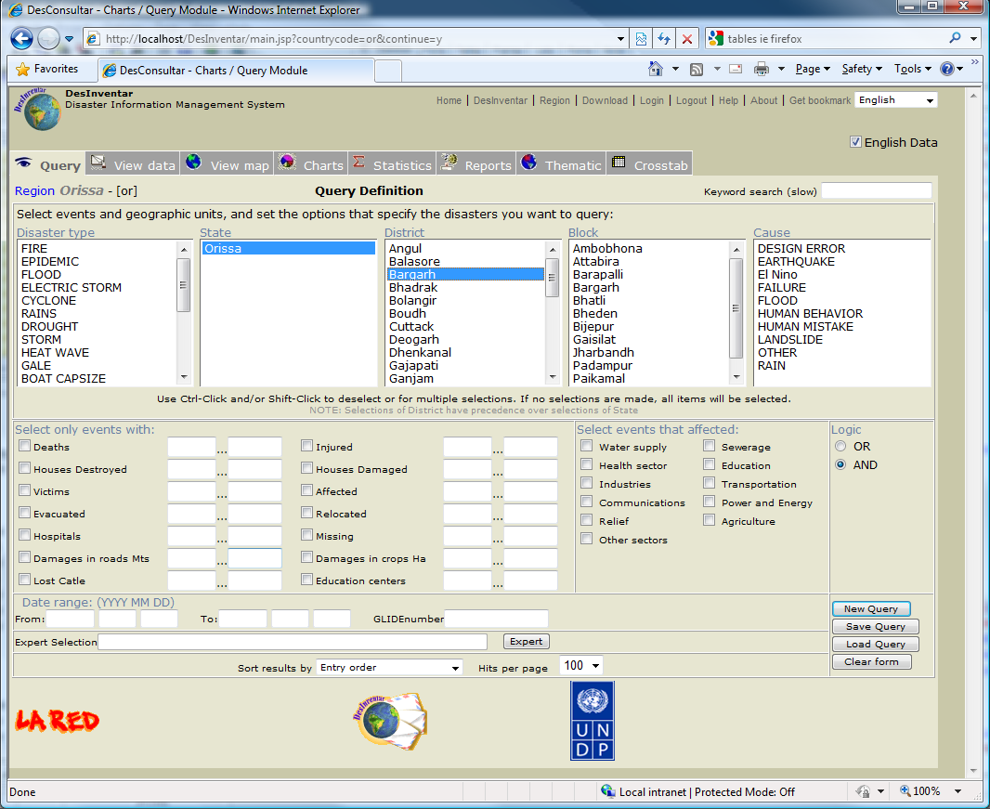
Graphic 2. DesConsultar’s main screen

Main Menu

This Menu (see Graphic 3), is permanently available both in the all of the Tabs of the Query module. Basically, it consists of:

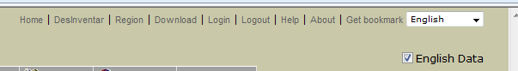
Graphic 3. Main Menu

Home:
This option is presented here so that system administrators can customize it to bring the user to the home of your Institution page. If not customized, it will jump to a welcome page with a brief description of DesInventar.

DesInventar:
Clicking this link will bring you to the DesInventar module (for data entry or administration purposes.). Note that this module may be password protected in which case instead of the module itself you will be presented with the Login screen (see Login and Logout options later in this section).

Region.
A click on this option opens again the first window (see Graphic 4) where you can choose the country or region of study you want to query.

Once your browser displays this screen you can select which region or country you want to query, just by clicking in the corresponding link.

Download:

Click here to get to the download page. In the download page the users can (usually) download the software of the system and/or the databases. This behavior can be modified by your system administrator.

Login:
These options may also be accessed using the tool bar located to the right of the map , and will be disabled if you are not seeing the map windows.

Logout:
These options may also be accessed using the tool bar located to the right of the map , and will be disabled if you are not seeing the map windows.

Help:
The Help menu gives you different ways to take advantage of the help system, which normally starts with the Table of Contents (first page). It is perfect to catch the spirit of the tool, and search quickly a general subject. Use the links in the text to get to other topics from here.

About:
This page gives credits to some Organizations that have supported the DesInventar Initiative.

Get bookmark:
Clicking on this link will instruct the system to produce a link in the address bar that can be used to set a page in the Favorites menu of Internet Explorer or a Bookmark in Firefox. This link can also be sent to other users when the DesInventar server is accessible over the Internet.

The Analysis Module ‘tabbed’ Interface

The most important feature of the Analysis Module is its ‘tabbed’ interface:

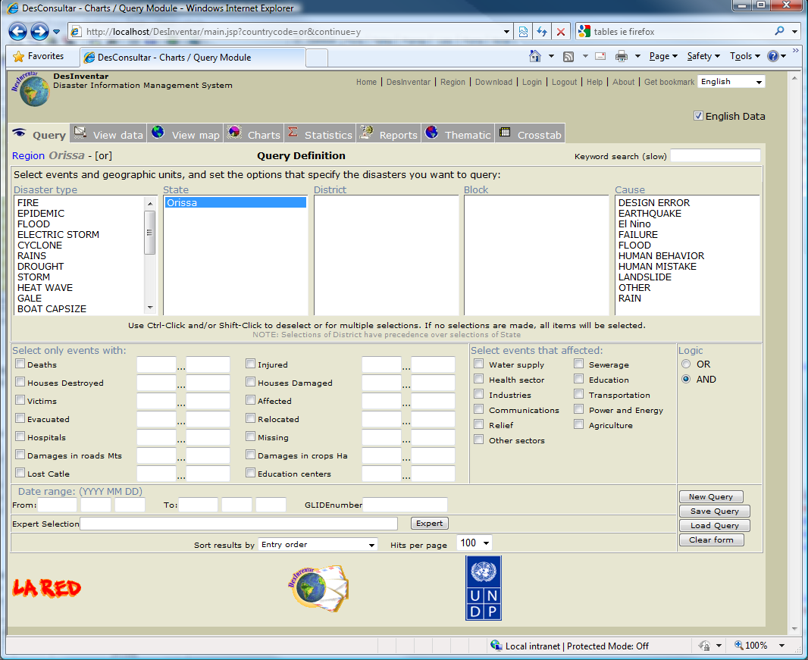

You can jump from any tab of the system to any other tab at any given time. That gives you, the user, a lot of freedom in the way you want to do your work.

For example, you can specify what datacards you want in the Query tab, and then jump immediately to the Statistics tab in order to obtain statistics about the resulting query.

You have to keep in mind that settings in each tab are remembered by the system (are ‘persistent’). For example you may select a type of Chart (in the charts tab), jump to the query tab to modify another setting, and jump back to Charts and still find your setting there.

The tabs that compose the interface are:

Query tab.

The main screen of the Analysis Module is displayed in this tab, where you determine what the information you want to see is.

Data tab

This tab will always contain the simple tabular form of the results of your query. You will be able to see here the datacards that comply with the specifications given in the Query tab.

Map tab

The Analysis Module is provided with facilities to handle very simple maps of the study regions.

Charts tab

DesConsultar can generate several very powerful types of charts in this tab with the information you retrieve from the system

Statistics tab

This tab provides aggregates of the different variables found in the Database. Statistics may be generated for multiple variables and for up to three customizable levels of aggregation.

Reports tab

DesConsultar is provided with facilities to generate customized reports. These reports can be obtained in the screen or as Spreadsheets.

Thematic Maps tab

One of the most powerful features of the Analysis Module is the generation of thematic maps based on the information of the database. Spatial analysis is made possible with these maps.

Crosstab tab

This tab provides aggregates of the different variables found in the Database organized as cross-tabbed tables. Crosstabs use always two dimensions (one vertical and one horizontal) as levels of aggregation.

The following chapters (one entire chapter per tab) explain in detail each of the tabs of the system.

The Query Window

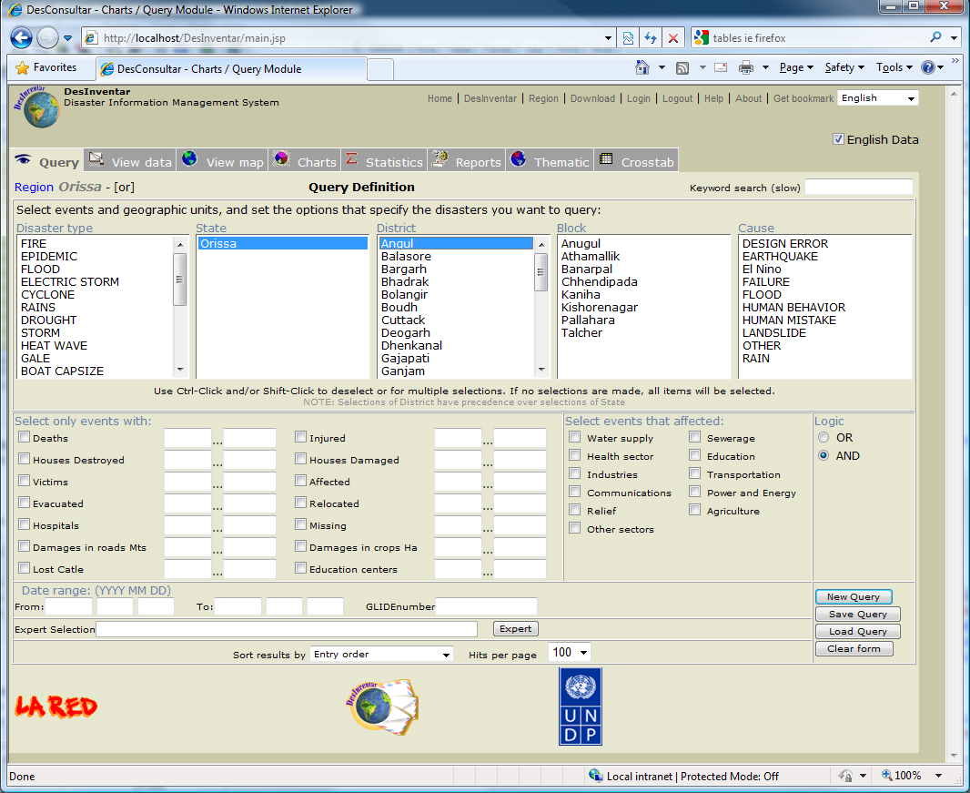
Graphic 2. the Analysis Module’s main screen

Description of the elements in the Query Window

Disaster Type

This is a list of all the events that have been defined. If you want a query (or report) on one or more events, select them from the list. As you select then they will appear highlighted.

If you DO NOT select any event, the query (report) will include ALL the events.

Click the event to select it. To deactivate, use cntrl-click (press the Ctrl key, and without releasing it, click it again).

Using a very standard MS Windows methodology you can:

- Select and deselect individual elements of the list with Ctrl-Click
- Select only one element with a single click
- Select a Range of contiguous elements in the list by Clicking in the first element and Shift-Clicking on the last.

To deactivate all the events, click on “Clear Form”.

Geography Level (State, Municipality, etc)

The geographic levels are showed on three lists (or two if only two geography levels have been defined) from which you can select the regions on which you need information.

As in the list of events, if you do not select something from a list, you are implying that you want information about all the regions at this level. Thus, if you select no regions in Level 0 list, the data cards of all the regions will be retrieved.

If you select regions from the Level 0 list, but you leave the Level 1 list with no selections, all the data cards of disasters occurred in the regions selected at Level 0 will be retrieved.

Note that the lists of Levels 1 and 2 appear initially empty. They are filled in only if a selection has been made in the previous level.

In the example, no selections are made in the level 0 List, thus no level 1 regions appear in Level 1. You could choose here some of the municipalities from the list.

Using a very standard MS Windows methodology you can:

- Select and deselect individual elements of the list with Ctrl-Click
- Select only one element with a single click
- Select a Range of contiguous elements in the list by Clicking in the first element and Shift-Clicking on the last.

Cause

Selecting causes from this list will restrict the results to those datacards in which this cause is set. As in the list of events, if you do not select something from a list, you are implying that you want information about all the causes.

Events with Specific Effects

For a more specific query, you can choose some event describers, such as Dead, Injured, etc. Click the empty box to the left of each alternative.

Depending on what you type:
- If the checkbox of the effect is set: Results will be restricted to those cards in which the effect happened.
- If the first of the To/From boxes is filled out, results will be restricted to those datacards where the effect was greater or equal to this number.
- If the second of the To/From boxes is filled out, results will be restricted to those datacards where the effect was less or equal to this number.
- Both numbers can be set, in which case results will be restricted to those datacards with this effect magnitude between the two values (and including the values as well).

Remember: if you do not select anyone, no restrictions will be imposed on what datacards will be selected.

Events that Affected…

Queries can be restricted, according your needs, to events that have affected the sectors “Agriculture”, “Education”, etc. Click once on the fields in “Events that Affected”, on the Query Window.

Remember: if you do not select anyone, all of them will be selected.

Logic of Selection

This tool is very useful when you need a more exhaustive query. For example, if you want to query events that have destroyed homes and affected public services, click the corresponding describers and select the option “Conjunctive”.
If you want to query events that affected the Industry or destroyed homes, select the option “Disjunctive”.

Date range: (YYYY MM DD)

As with the lists, using them or not using them will determine whether or not the datacards are within the dates displayed. If you do not use the date From, the datacards will be displayed with no restrictions, except for those resulting from the date UNTIL. The same applies to “To” dates.

If you type the date “From” only, all the cards with a date equals or later to “From” date will be retrieved.

If you use the date “To” only, the cards with dates prior to the one indicated will be retrieved.
If you include both dates, the cards whose dates are within the period specified will be retrieved.

It is important to clarify that if you enter a year as a date, you must also enter the month and the day. Otherwise, January 1st will be taken as the rest of the “Since” date, and December 31 as the rest of Until date . This is particularly important in the case of the “UNTIL” date. If you enter the year only, only the cards of THAT AND PREVIOUS YEARS will be retrieved.

Ordering

This field refers to the order in which you want the datacard to appear on the Datacards viewing sheet (see Graphic 3). Just click one of them.

IMPORTANT: this order specification is valid only for queries (using the “View Data” button). For statistics, the criterion applied is taken from the aggregation levels.

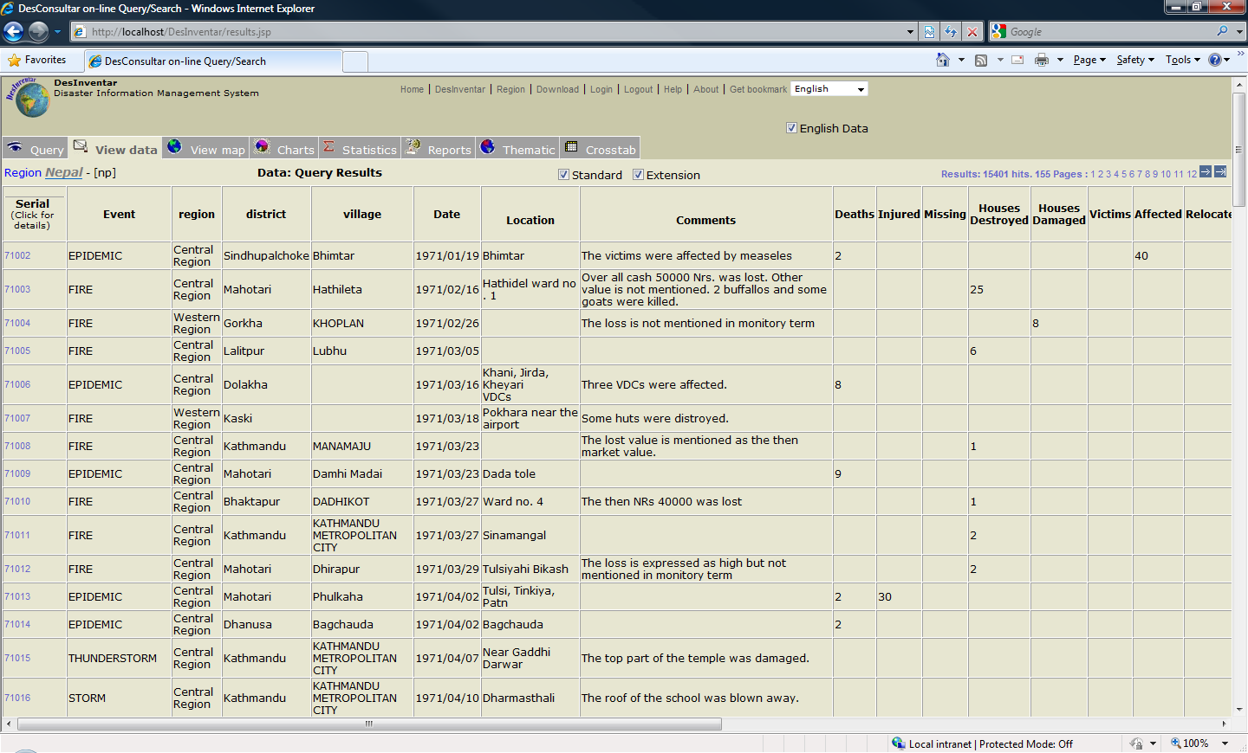
Graphic 5. Datacards viewing tab

When you finish making your selection, you can see the information by clicking on the button “View DataCards”:. Data is presented on a spreadsheet (see Graphic 5). This window is called the DataCards Viewing Sheet. Use the vertical and horizontal scroll bars, or use the buttons to send data to printer or to be represented in graphics.

The other elements in the Query Window are the buttons that activate:

- The Data Expert: This opens a pop-up window in which a mathematical expression may be constructed using the variables of the system. Results will be restricted to those datacards in the system where the evaluated value of the formula is different from 0 (or false).

- Query Buttons “New”, “Save” and “Open Query”, described below.

The Data Expert

Regarding the “expert” buttons (illustrated in Graphics 2), actually are doors to the universal language of database query and management: SQL (Structured Query Language).

This window should be operated by a person with some experience in computers, especially in the area of databases, and familiarized with these concepts.

The variables appear in the box to the bottom-left of Graphic 6; to use them in SQL, find the variable and make a double click. Regarding the operators, one click is sufficient to assemble the query. A click on “OK” must display something similar to Graphic 3, which would be the result of the query. If there is any error, read carefully the description; take into account the relevant parenthesis, and make sure that the words typical of SQL are correct (Select, from, where, order by).

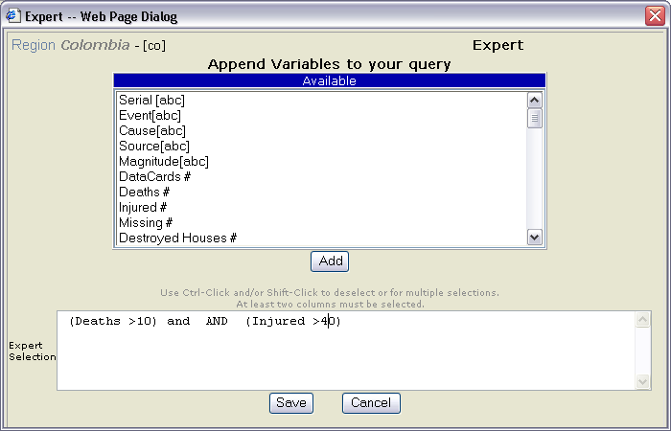
Graphic 8. The expert: an advanced query system

With this language, an average user can “make questions” to a database, especially to related databases as that of DesInventar’.

This window shows in a box the question SQL, which corresponds with that which the user specified in the Query Window. For example, if you make a query choosing the event FLOOD only, the SQL question will look pretty much like this:

select * from datacards where event='FLOOD'

As you select events, geographical units, dates and other possible conditions for data retrieval, the SQL question becomes more and more complex. For example:

select * from cards
where ((event='LANDSLIDE') or (event='FLASH') or
(event='HURRICANE') or (event='SEDIMENTATION')) and
((level0='05') or (level0='08') or (level0='17') or
(level0='23')) and
(((dateyear*373)+(datemonth*31)+dateday)>= 740437) and

((deaths<>0) OR (injured<>0) OR (health<>0))

order by event, name0, name1, name2, dateyear, datemonth, dateday

This question asks four possible types of event, in four Level 0 regions (Dpts...), limited to a date, where people were killed, or injured, or the health sector was affected, ordering the result by event, geography and date.

Query Buttons

New Query

This button erases all the selections marked in the fields of the Query Window. All querys will be deleted or not, prior confirmation, with a double click.

Save Query

This button allows you to save the current status of your selections in:

- The Query Window
- Events selected
- Geographical zones (in their three levels) selected
- Causes selected
- Dates specified
- Effects required
- Sectors affected
- Ordering
- Type of logic linking (conjunctive - disjunctive)

- The Generator of Thematic Maps
- Texts and titles
- Variable chosen
- Ranges, limits and captions used in the Thematic Maps section
- Convention type and other “settings”

Open Query

With this button you can make the above operation the other way around. You can retrieve the status of your selections from the Query Window, and titles, variables, ranges, limits and captions saved in the Thematic Map section.
.

The Map Window

DesConsultar is provided with facilities to handle very simple maps of the study regions.

These maps serve three purposes:

- Show users the shape, size and location of the zones forming the division (usually political/administrative boundaries) used to geo-reference the data.
- Serve as a tool to select specific zones of which information is required. The application is particularly useful for users who do not have a practical knowledge of the study region.
- Serve as initial model for the production of thematic maps. See more information in the corresponding section.

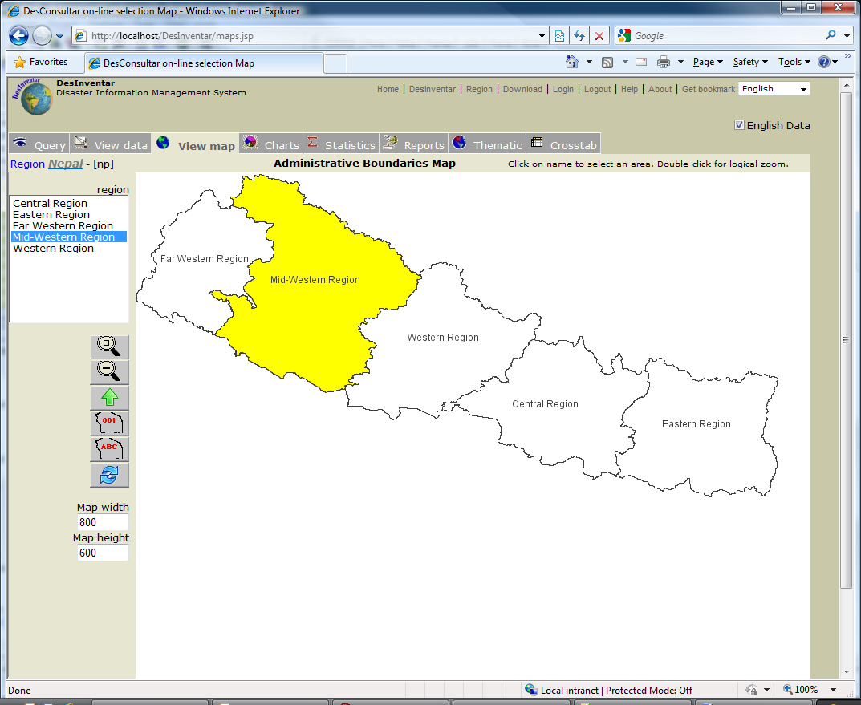

Graphic 6. Map Window of the Analysis Module

Also, the window allows seeing the zones selected on the Query Window.

To reach the Map Window, click on button “View Map”. You can identify the zones selected on the map for data retrieval; for they appear in yellow (see Graphic 6).

From this window you can also select the geographical areas of interest in a visual interactive manner: a tool bar is displayed to the right of the map, with the following options:

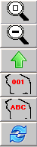Zoom (Enlarge) Map. When you select this option the system enlarges the map by 25%.

Reduce Map. This option reduces the map size by 25%.

Map showing Names. This option displays the names of the geographical areas, instead of the codes. Depending on the density of the geographical (or political-administrative) areas, the map might result illegible due to overlapping of the names. In this event, it would be advisable to enlarge the map.

Map showing codes. This option displays the codes of the geographical areas, instead of the names.
Depending on the density of the geographical (or political-administrative) areas, the map might result illegible due to overlapping of the codes. In this event, it would be advisable to enlarge the map.

Map refresh. This option will force a re-display of the areas. names.

One leve up: after drilling down to one area you may click here to get back to the previous higher level.

List Of geographic Units. You can use here a list similar to that of the Query Window to choose your sub-divisions on the map.
This tool is ideal to find in the map a geographical unit whose location you do not know. Select with mouse one or more units from the list, and the system will fill the units selected with yellow (this means it will select them).

Usually bowsers provide additional functionality right-clicking in the map. Usual functions find in right click menus are:

Copy Map. Right click and select “Copy”. When you use this option a copy of the content of the Map Window will be taken to the clipboard.
This function, one of the most powerful characteristics of WINDOWS, allows you to interchange results and data between the different applications, using the tool “Paste”.
This procedure can be used in word processors to insert a map in a text, or in drawing programs (Paintbrush, for example), etc.

Producing charts

Everybody knows an image is worth a thousand words. One of the main strengths of the Analysis Module is the ability to present the data about disasters in graphical form, as charts.

Charts are excellent means to represent the behavior of a variable along time, of to compare variables against each other.

DesConsultar charts are focused on these two types of results. During the process of Analysis of the data, many other types of charts may be designed and produced. There are some fantastic tools in the market with charting capabilities beyond those of the Analysis Module.

However, the Analysis Module can provide data to those systems using the previously described functions of Querying data, Report generation and Statistics.

The mechanism of producing Charts with the Analysis Module involves a similar process as with the other result generators: a definition of a query based on selection of geographical units, event types, range of dates and several data characteristics.

Once a query is satisfactory, its results can be charted in the several formats, selected in this screen:

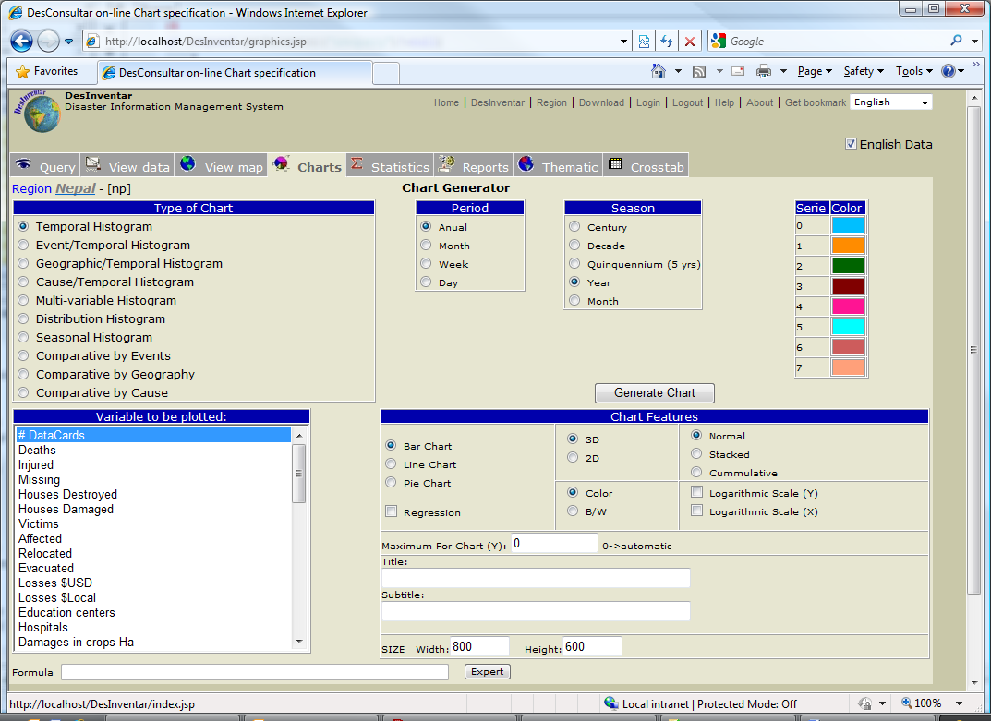

Graph Specifications

Type of graph

Time Histogram
Generates a simple histogram according to the variable selected for graphing. The occurrence frecuency (Y axis) of the variable to be graphed will be displayed according to the period selected in the Period window, which defines the time intervals (X axis). This graphic is generated as bar or line chart.

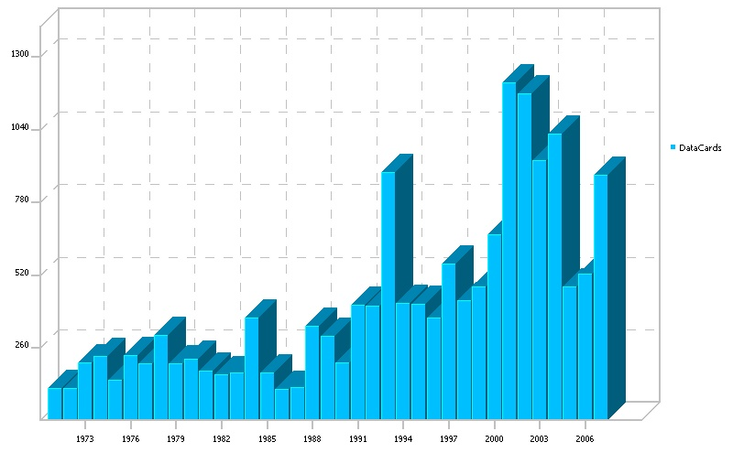

Event/Temporal Histogram
If the user has selected up to six types of events in the query, this histogram will represent the values that correspond to the variable that is to be graphed, in each class interval, differentiating each event series by colors. The conventions for event type will appear on the right. Note: this type of histogram will not be displayed if the user has selected more than six variables, this will be notified to you by the appeareance of a message. This graphic is generated only as bar or line chart.
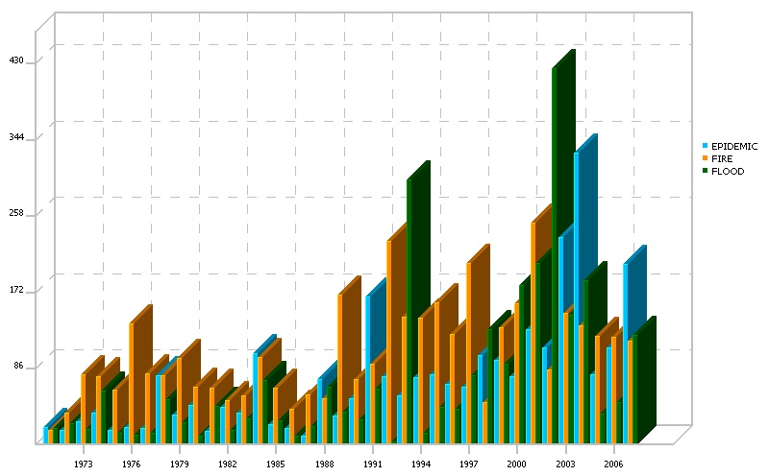

Geographic/Temporal Histogram
If the user has selected of up to six geographical units in the query, this histogram will produce the representation of values of the variable to be graphed. It works similarly to the previous Event/Time Histogram graph. This graphic is generated only as bar or line chart.
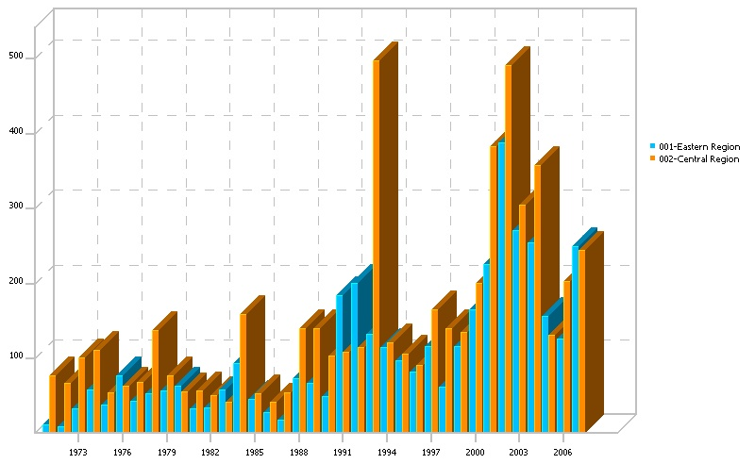

Multi-Variable Temporal Histogram
If the user has selected of up to six Variables to be plotted, this histogram will produce a histogram with one series for each variable. This graphic is generated only as bar or line chart. In the example below, a Variable histogram of Houses and houses destroyed.

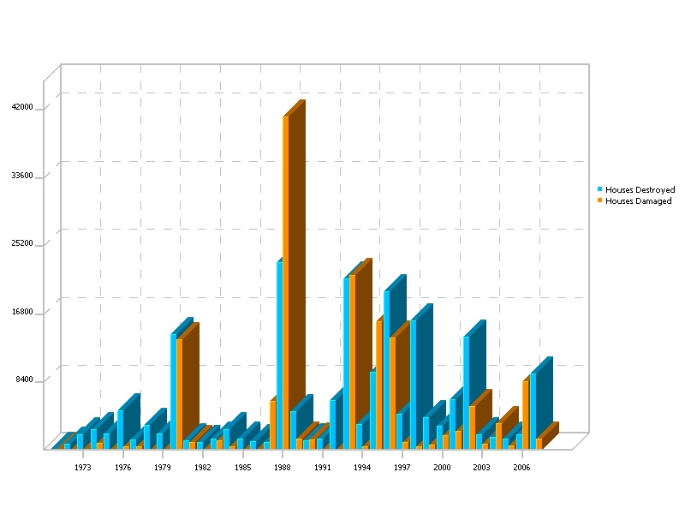

Seasonal Histogram

Seasonal histograms display accumulated frequencies of the variable that is to be graphed, during the selected season and at a level of detail defined by the Period. The season, of course, must be longer than the period.

A typical (and most natural) example is a yearly season. In this case all the values generated during January will be accumulated in the first bar, the values of February in the second, and so on.
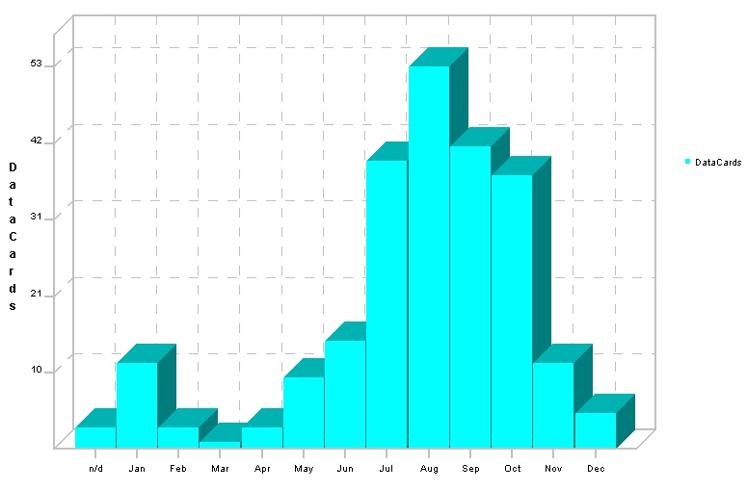
It is recommended that the user first selects the type of season according to the date range of the query. DesConsultar will suggest a Period suitable to each type of season, which can be modified by the user. If you make an incorrect choice, a warning will be displayed indicating that “the period must be shorter than the season”. This graphic is generated normally as bar or line charts.

Comparative by Event
It displays a Pie chart, proportionally segmented according to the values aggregated per Event for the variable to be graphed. On the right, the conventions that correspond to the events selected in the current query will appear. This graphic is generated as bar, line or pie charts.
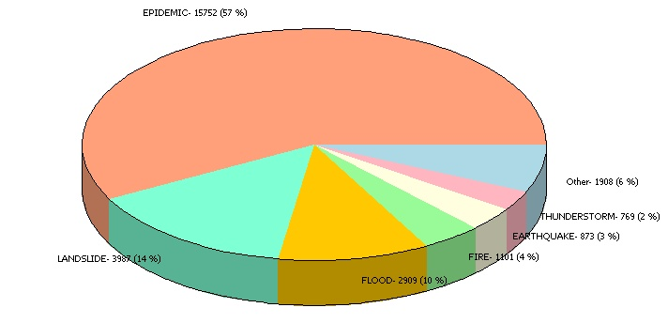

Comparative by Geography
It is a comparative that is similar to the Event Comparative, only this one is aggregated by geographical regions instead of event type. This graphic is generated as bar, line or pie charts.

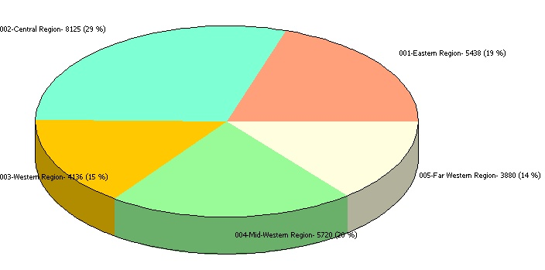

Period
Allows selecting a unit of time for the display of information in all Histograms:

• Annually
• Monthly
• Weekly
• Daily

Season

With this option, multi-temporal histograms can be created. When using it, it is recommended to select first the type of season as the Analysis Module will suggest the recommendable analysis period.

This type of chart is particularly useful to formulate hypothesis and verify correlations with climate variables or other types of variables and particularly with all of those that present periodic behaviors (or almost periodic) and those with secular variations. For reasons of visualization, the intervals of class cannot be greater than 1000.
• Century=100 years
• Decade=10 years
• Five-year period= 5 years
• Year
• Month

Variable to graph
There is a list of possible variables to graph, such as the number of events, the effects that the disaster produced or the losses it has left. Based on the current query, the Analysis Module allows charting variables one by one. In the case of Event and Geographic Histograms, it allows to graph the effects of up to six types of events or geographical choices,

Titles

Main Title: Allows identifying each graph (histograms and pie) with a title that will appear horizontally on top of the chart. There can be up to 65 characters (including spaces) entered.
Subtitle: It allows enlarging or clarifying the legend of the title; there can be up to 45 characters entered (including spaces).

Colors
The user may select either displaying graphics with full collor or in black and white. If the full color choice is selected the Analysis Module will assign colors automatically.

The user may later edit the colors exporting the figure, with the option Copy, to graphics editors. If the choice is black and white, the Analysis Module will assigne the fill in type automatically.

Appeareance
There are two options to choose from, Three-dimensional (3D) and Two-dimensional (2D) for graphs of bars or pies; for lines only is possible in 2D appeareance. For more clarity, its recommended that you use two-dimensional when there are more than 30 class intervals .

Graph type

Bar
Generates a bar chart, typical in histograms.

Line
Represents the frequency of occurrence values of each class interval by means of a continous thick line. Additionally, it graphs the linear regression with dotted lines.

Pie
Draws the results in form of a cake or ’pie’, indicating the values that were obtained for each selection.

Graph Mode

Normal
In this mode the system will show a histogram, line graph or pie with the values exactly as retrieved from database.

Accumulated

The class intervals accumulate sequentially the values for frequency of occurrence.

When there are databases that are homogeneous in space and time, these type of graphics is particularly useful to evaluate the tendencies of the frequency of ocurrence of the effects or phenomenna of interest. This graphic is valid only for bars or lines diagram.

Stacked chart
For the Event and Geographic histograms with the bar option in Graph class, it allows to visualize the values of geographical units or events selected (six as maximum) on the same bar. The difference with Normal mode for these two types of histograms is that in the Normal mode there are as many bars graphed as the number of events or geographical units selected. This graphic is valid only for bars diagram.

Graph Operations (right-click):

Copy
Allows copying the image on screen and pasting it in other applications.

Print
Displays the standard print dialogue for printing.

Save
Generates a BMP format graphic archive.

The Statistics Generator

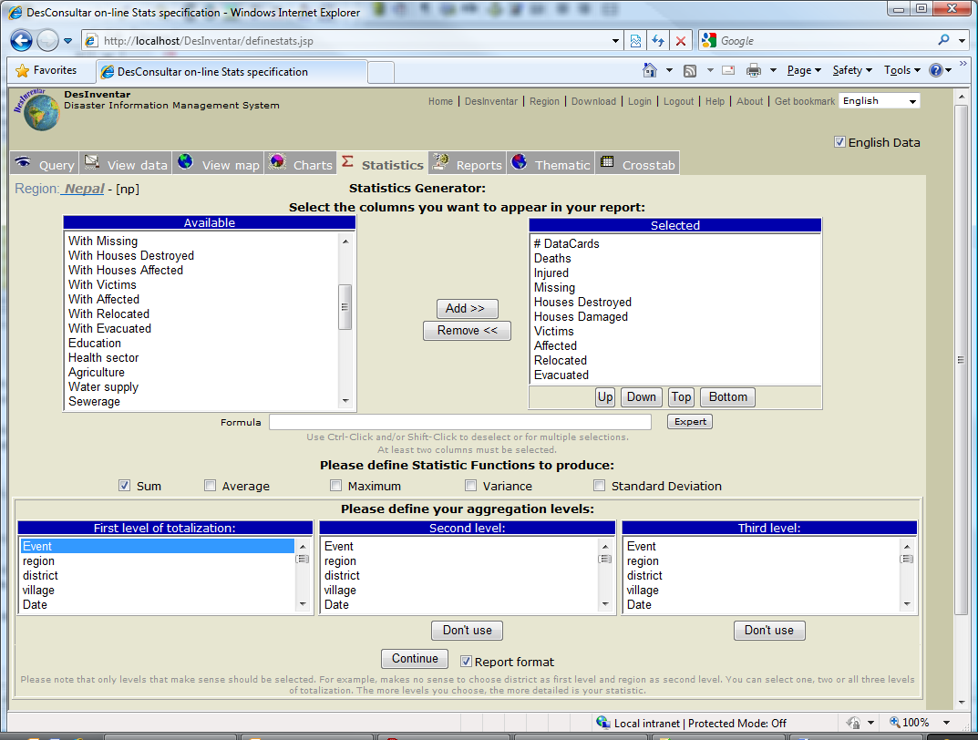
Graphic 7. Statistics Generator

The statistics provided by this tool can also be observed from the main window, using the button “Statistics”. This button displays a window (see Graphic 5). It has been designed to obtain global and semi-detailed results from the databases.

Totalization Levels.
Correspond to three lists containing the different posibilities of data aggregation, including the Date, Cause, Event, Geography Level, etc.

The fields of each level are mutually exclusive. For example, if you choose Geography Level 0 in the first level, and YEAR in the second, they will be excluded from the third totalization level.

A click on “Continue” will display a spreadsheet containing information similar to that in Graphic 5 (datacards viewing sheet): a statistical summary of the query made in this window.

The Thematic Map Generator

The “Thematic Map” tab generate colored maps that can show the spatial distribution of the query’s data.

A click on this button displays a window (see Graphic 9) to generate the map. A set of options is displayed.

You can choose to generate displaying complete Level 0 units (Estado, in the example) or Level1 units (Municipio in the example). This is known as the Selection level.

You also can choose how detailed the map will be: Level 0, level1 or (if applies) Level 2. This is known as the level of representation, or Output Level.

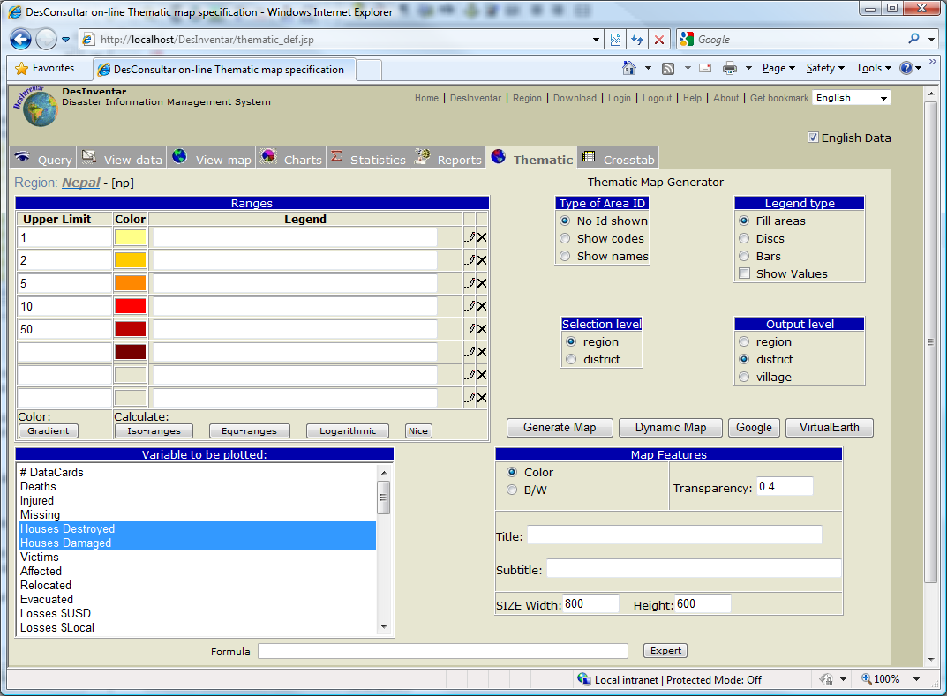
Graphic 9. Generating a Thematic Map

If you want the map to show the areas identified, you can choose from three presentations: names, codes or centroids, or without identification. “Type of Convention” refers to the forms in which the variable to be represented graphically will appear; they can be:

- Fill Areas: the geography level selected for display will appear with the colors corresponding to the range defined in the field “Ranges, Captions and Colors”.

- Discs: circles of different color and size will appear, according to the range of each value.

- Bars: Small vertical bars of different color and size will appear, according to the range of each value.

- The system can also display or not the value that is being represented graphically as a number at the centroid of the polygon, to one side of the identification selected, if any.

Regarding the “Variables to be plotted”, they are presented in a list with the quantifiable descriptor variables of disasters that can be represented graphically. Among them, you will find Effects and Disasters. To select a variable, click on it. If you want to choose another, click on the other and the first one will de deactivated. You may choose one or more variables. If more than one variable is chosen, the sum of the variables will be plotted.

Regarding ‘Ranges, captions and colors’, they are specified in three columns as follows:

- Upper Limit: type here, from smaller to larger, the upper limit of the ranges

- Caption: type here the title for each range. If you do not type anything, the system will generate a caption automatically according the ranges.

- Color: to change the colors of each range, click the color you want to change, and then click another in the color palette at the bottom of the window.

A click on ‘GENERATE MAP’ will display the thematic map (see Graphic 9) with the specifications determined in the window represented in Graphic 8.

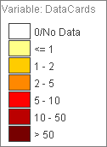
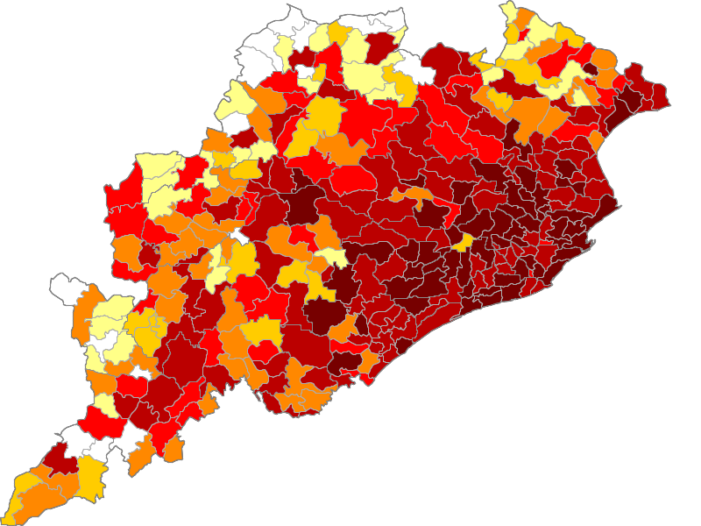
Graphic 9. Thematic Map

Maps can also be generated superimposed to three external maps providers, namely Dynamic – using PREVIEW (Risk maps)-, Google and Virtual Earth.

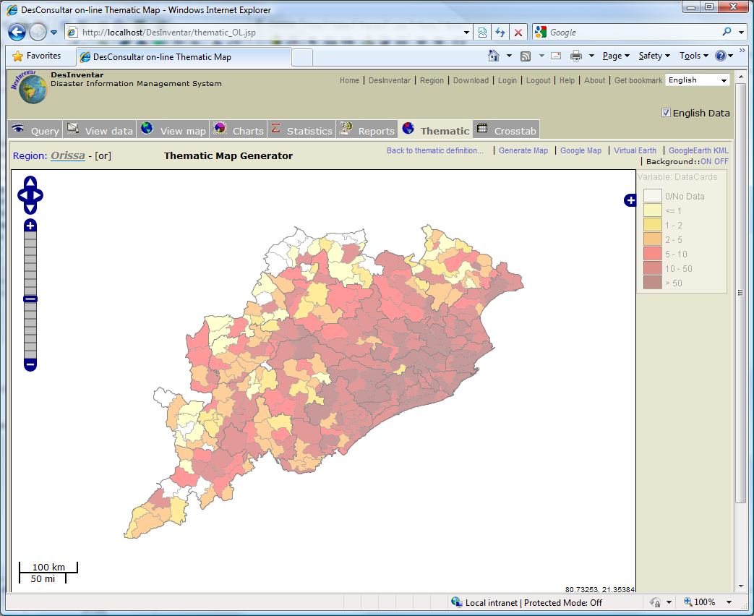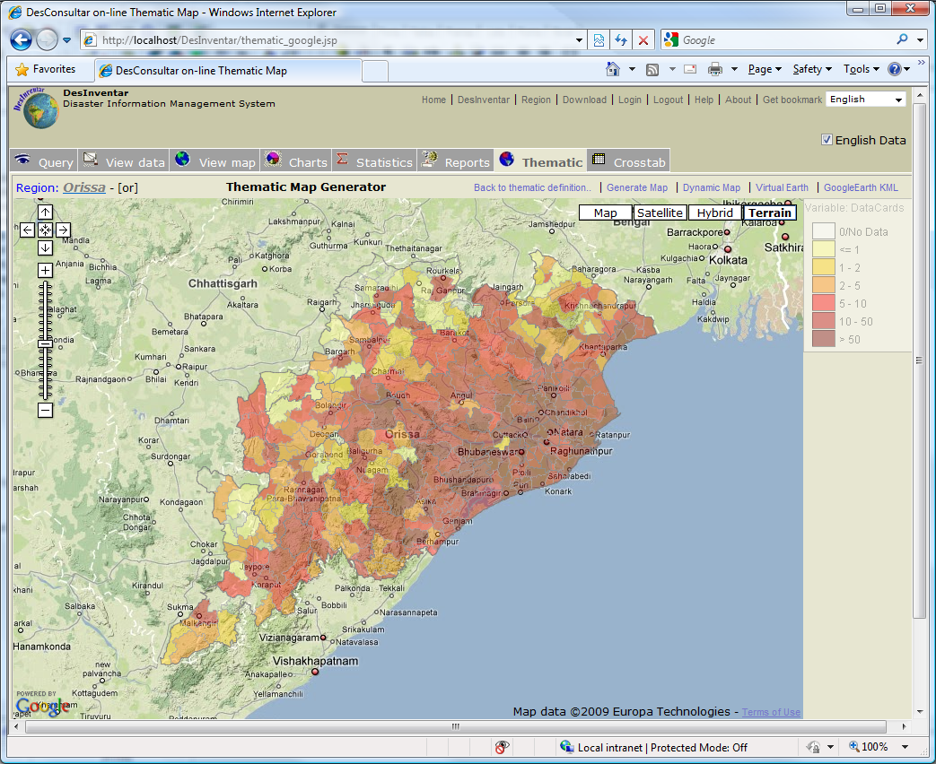

With these map providers DesInventar Maps can be overlaid to road and general maps (all providers), satellite imagery maps (all), terrain (Google), and Hazard/Risk maps (PREVIEW). In order to activate the Risk Layers, click on “Background ON”,

These maps cannot easily be copied; The best way is to use ALT-PrtSC keyboard combination and then paste and trim the resulting image.

The Data Card Window.

The Disaster Card or Data Card Window (See Graphics 14 and15) is the same one used in the Data Entry module DesInventar. As the main purpose here is to query, buttons Search, Print and End are included, and the buttons Create and Modify Data were excluded).

You may open this window from the Results tab. At the left of each Datacard (row of results) the Serial number is a link that will open the datacard and show all the info of the datacard (record) in a compact, printable way.

The content of the card is divided into several sections:

Header

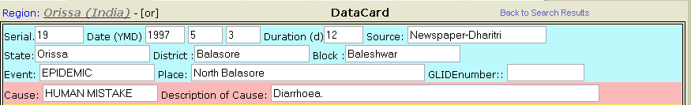
Graphic 14. Query Data Card Header

Header Fields.

- Card Serial Number. This field shows the number that identifies each card, which can appear in different notations, according to the criteria of the person who has written it.

- Card Date Field. It shows the date on which the event was registered, in this order: year, month, day.

Letters YYMMDD remind you of the order of the date.

- Duration. This field informs the duration of the event.

- Card Information Source. Specifies the entity or entities, the information means from which the information was obtained.

- Level 0 Field of Geography. This level corresponds to the geographical level (or political-administrative division) immediately below the Country level. For Mexico, for example, this level is called State; for Argentina, Ecuador and Costa Rica, it is called Province.

- Level 1 Field of Geography. This level corresponds to the second classification or political-administrative zoning of a country. It changes according to the country: municipalities, cantons, etc.

- Level 2 Field of Geography. Corresponds to the third classification or political-administrative zoning of a country, and it also changes according to the country.

- Event. Corresponds to the type of event, whether natural or technological, related to the disaster inventoried.

Below is the list of the types of event included in the database generated by DesInventar, in alphabetical order. For analysis purposes, it might be advisable to group some of the events in the Analysis Module. For example: “flash”, “alluvium”, and “avalanche” in one category, and “rain”, “gale” and “storm” in another. In a more general manner, several disasters (technological, meteorological, etc.) may be grouped in regions showing similar characteristics.
The words selected by DesInventar to designate the types of events are not “orthodox” for disciplines such as geology, meteorology, etc.; the purpose is just to come closer to the most common designations used in Latin American countries for the phenomena. The selection was made based on several Spanish dictionaries and technical glossaries, although the search was not exhaustive. The point is more to provide a set of terms as homogeneous as possible, useful for projects, obtained from non-specialized sources in different countries.

Accident
Automobile, rail, aircraft or navigation accidents. Limited to accidents induced by natural phenomena, such as landslides, earthquakes, hurricanes, rain, etc. Includes transportation accidents generating spills or leaks of harmful substances, regardless of the cause.

Avalanche
Swift sliding of loosened ice and/or snow masses.

Alluvion
Torrential water flows dragging large amounts of solid material (pebbles, stones, and rock blocks) common in dry regions or river beds produced by heavy rain. Equivalent to the term “huaico” used in Peru.

Flash-flood
Torrential freshet. Violent water flow in a watershed, overflowing or as torrent. Flash-floods usually carry tree trunks and/or abundant fine to bulky sediment. They can be caused by rain, dam bursting or abundant landslides on a watershed or basin.

Biological Event
Destruction of biological species for known or unknown reasons. In the end, these events may be associated to pollution or drastic changes in environmental parameters. An example could be the “red tide”.

Pollution
Concentration of polluting substances in the air, water or soils, at levels harmful to human health, crops or animal species.

Landslide
All mass movements other than surface erosion of a hillside. This event includes terms such as precipitation of earth, settling, horizontal land thrust , mass movement, displacement, subsidence, collapse of caves or mines, rock falls, (slow or quick) detachment of soil masses or rocks on watersheds or hillsides. This event includes report of “faults” in hillside slopes or cuts, roads, canals, excavations, etc.

Epidemic
Disease attacking many individuals in a same community during short terms (days, weeks, months maximum), such as cholera, typhoid, bubonic plague, etc.

Eruption
Volcanic eruption with disastrous effects: eruption and emission of gas and ashes, stone falls (pyroclast), flows of lava, etc. This event includes eruption of sludge volcanoes found in some Caribbean regions.

Leak
Leak of harmful liquid, solid or gas substances, whether radioactive or not, generated by technological accidents, human fault or transportation accidents.

Structural Collapse
Damages or collapse of any type of structure for reasons such as excess weight in public places, bridges, etc. This event includes damage that, although not taking the structures to the point of collapse, does make them unusable. Damages in structures caused by natural phenomena are reported as an effect of these phenomena.

Explosion
Explosions of any type, but limited to those induced or highly connected to natural phenomena, such as electrical storms, earthquakes, droughts, etc.

Forest fire
Forest fire. The event includes all open-air fires in rural areas, natural and artificial forests, plains, etc.

Hailstorm
Precipitation of hail. Frozen raindrops that fall violently in the form of hard pellets.

Frost
Temperature low enough to cause freezing, with damaging effects on population, crops, properties and services.

Hurricanes/Cyclones
Violent atmospheric anomaly characterized by strong whirling winds accompanied by rain. They are originated in the Caribbean Sea and tropical areas of the Pacific Ocean. They are equivalent to the cyclones in the Indian Ocean and to typhoons in the West Pacific Ocean.

Fire
Urban, industrial or rural fires, but not including forest fires. Limited to those induced or highly connected to natural phenomena, such as electrical storms, earthquakes, droughts, etc.

Flood
Water that overflows river-bed levels and runs slowly or quickly on small areas or vast regions. Tidal flooding in coastal zones will be reported as “Tidal wave”.

Coastal erosion
Variations of the coast line and/or maritime zones near the coast. Includes formation and destruction of islands, beaches and sand banks and erosion of cliffs affecting populations, navigation, etc.

Rain
Precipitation. Includes punctual, persistent or torrential rain, or rain exceeding the rainfall averages of a specific region; also, unusual long rain periods. Rain includes terms such as downpour, cloudburst, heavy shower, deluge, persistent drizzle, squalls, etc.

Tidal Wave
Great sea waves breaking on the littoral. Includes reports caused by hurricanes, gales, storms -other than tsunami or seaquake, in the strict sense indicated under “tsunami”- by coincidence of wind directions and high tide periods, or by rise of average sea level during the phenomenon “El Niño”. In some places, tidal rises reaching maximum bimonthly levels or up to maximum annual levels are called "high tide".

Snowfall
Anomalous fall and accumulation of snow, especially when it occurs in zones not subject to seasonal changes. This term refers to events where precipitation exceeds the average multi-annual values, causing especially serious effects.

Heat Wave
Rise of atmospheric average temperature well above the averages of a region, with effects on human populations, crops, properties and services.

Cold Wave
Rise of atmospheric average temperature well above the averages of a region, with effects on human populations, crops, properties and services.

Panic
Panic o mass hysteria among people concentrated in a certain place (stadiums, theaters, etc.) that can kill or injure them, and cause physical damage. Limited to those induced or highly connected to natural phenomena, such as electrical storms, earthquakes, etc., and early warnings about incoming events.

Plague
Proliferation of insects or animal pests affecting communities, agriculture, cattle or stored perishable goods; for example, rats, locusts, African bees, etc.

Earthquake
All movements in the earth’s crust causing any type of damage or negative effect on communities or properties. The event includes terms such as earth tremor, earthquake and vibration.

Sedimentation
Deposits of solid material on hillsides and river beds produced by mass movements or surface erosion with damages on crops, utilities or other infrastructure.

Drought
Unusually dry season, without rain or with rain deficit. As a whole, these are long periods (months, years, and even decades) typical in limited continental areas or on regional scales.

Storm
Rain accompanied by strong winds and/or electric discharges (lightning). Due to regional connotations, sometimes there is no difference between “storm” and “gale”.

Thunderstorm
Electrical Storm: concentration of atmospheric static discharges (lightning), with effects on people, cattle, domestic properties, infrastructure (mains, for example, causing blackouts), and industries. It is different from “storm” in that thunderstorms are not accompanied by rain and gusty winds.

Tsunami
The term is applied only to waves generated by undersea movements (caused by earthquakes, volcanic eruptions or landslides).

Gale/Tornado
All atmospheric disturbance generating strong and destructive winds, usually without rain or little rain. The term is synonym of hurricane-type winds, whirlwind, squall, cyclone, strong wind, blizzard, wind-blast, gust, and tornado.

Boat Capsize
Overturning of a boat due to hitting the water-bed or due to sea-disturbances.

- Site. This field shows the place where the event occurred.
If this place corresponds exactly with the last geographical level reported, it might not appear. This site normally specifies the exact place where the disaster occurred within a municipality, a canton, or a geographical unit reported.

- Causes. Since sometimes it is difficult to differentiate the cause from the effect of the phenomenon itself in the generation and development of an event that ends up in disaster, each research team may include the causes of an event in “Comments”.

Behavior
It usually refers to disasters or emergencies caused by panic, or resulting from cultural causes of floods or landslides.

Landslide
As a cause of road closures, accidents, isolation of people or property, sedimentation, flash floods, etc.

Design
Design and/or construction errors or defects in civil work, industrial installations, infrastructure systems, etc., which lead to collapses, accidents, explosions, leaks, flash-floods or floods (for example, bursting of dams or dykes).

El Niño
As a phenomenon that causes global or regional climatic anomalies, such as rain, drought, and derived types of event. Many newspaper reports attribute higher or lower precipitation to El Niño. Entry of El Niño events (or “ENSO” ) must include strictly those reported as such. For the last two decades, they are: 1982 to 1983 (very strong), 1987 (moderate) and 1991 to 1992 (moderate?).

Fault
As a cause of seismic activity, cracking of civil work or vital infrastructure networks, etc., in the strict sense of geological fault (see “Fault” in Type of Events).

Flood
As a cause of sedimentation, epidemic, etc.

Rain
As primary or triggering cause of floods, flash floods, landslides, accidents, etc.

Seismic activity
As generator of tsunamis, landslides, liquefaction, flash floods, structural damage, fire, explosion, accidents, changes in coastlines, etc.

Deforestation
As a cause of floods, landslides, etc.

Other Cause
Classify under “other cause” causes that have not been classified.

Effects
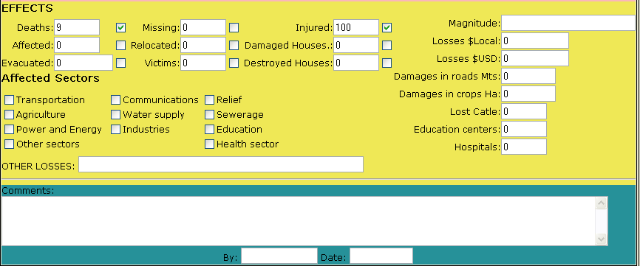
Graphic 15. Effects

On People

Dead
Corresponds to the number of people who died due to direct causes, whether immediately or time after the disaster.

If final official data are available, they must be included with the relevant comments. For example, when official figures differ from those of other sources.

Assumptions about deaths not officially verified must be registered under “Comments”, stating the information source.

Injured
Corresponds to the number of persons with bodily injuries. Bodily injuries, and, if the cause is plague or epidemic, the sick must be included.

Missing people
Number of persons whose whereabouts as from the effects of the disaster are unknown. It includes people presumed dead without physical evidence. Data on dead and missing persons are mutually exclusive; therefore, avoid grouping them.

Victims
Number of persons whose individual or collective property and/or services have suffered serious damage directly associated to the event. For example, total or partial destruction of homes and property; loss of crops and/or warehouses, etc. This group also includes evacuees or resettled persons, whether temporarily or not. If the information is available by family, the number of persons must be estimated based on indicators available.

Evacuees
Number of persons temporarily evacuated from their homes. If the information is available by family, the number of persons must be estimated based on indicators available.

Resettled persons
Number of persons who have been moved from their homes to new permanent sites. If the information is available by family, the number of persons must be estimated based on indicators available.

Affected persons

Number of persons who suffer indirect or secondary effects associated to a disaster. These persons, different from “victims”, suffer the impact of secondary effects of disasters for reasons such as deficiencies in the provision of public services, the hampering of trade and work, isolation, or their mental health may be affected. If the information is available by family, the number of persons must be estimated based on indicators available.

On Infrastructure

Destroyed homes
Houses that have collapsed, or have been swept, submerged or damaged in such a manner that they are not habitable.

Affected homes
Number of houses that suffered minor damage other then structural or architectural, and continue to be habitable, although requiring basic repairs and cleaning.

Other Effects on infrastructure

Quantitative

Roads - Mts.
Extension in meters of road networks destroyed and/or unfit for use.

Hectares
Crop, pasture or forest areas destroyed.

Livestock
Number of animals lost.

Education Centers
Number of nurseries, schools, universities, training centers, etc that were destroyed and/or affected.

Hospitals
Number of local and regional health centers, clinics and hospitals.

Indicators
Vital lines, public and production infrastructure that suffered an effect:

Transport
Road networks, railways, transport terminals, airports, river and seaports.

Agricultural
Crops, farms, pasture zones.

Communications
Telephone plants and networks, radio and television stations, mail and public information offices.

Power
Dams, substations, transmission lines, generation plants, processing plants, fuel deposits, oil and gas lines.

Education
All related to this sector: nurseries, schools, universities, training centers, etc.

Rescue Departments
Fire departments, Civil Defense, Red Cross and public order entities.

Water Supply Systems
Intakes, treatment plants, aqueducts and canals conducting drinking water.

Sewerage
Networks for disposal of waste and/or rain water; treatment plants.

Industry
Industries of all types and sizes, including agricultural and livestock industries.

Health
Local and regional health centers, clinics, hospitals.

Losses

Loss Value
Amount of direct losses in present value (local currency).

Loss Value in US dollars
Amount in dollars equivalent to the losses entered in the previous field, based on the exchange rate in force the date of the disaster. This value is useful to make comparative evaluations.

Other losses
Very short description (may include estimated value) of losses due to indirect or induced effects attributable to interruptions or deficiencies in the provision of public services, the hampering of trade and work, and geographical isolation.

Magnitude
This alpha-numeric field is used to enter international magnitude values for seism, volcanic eruption, tsunami, hurricane – tropical storm.

For other cases, you may enter quantified variables such as wind speed; heights of flashfloods and floods in meters; 24-hour rainfall in specific places; area or volume of landslides or deposits. We recommend to use always the same units for each type of variable: km/hr, m, mm/day, m², m³, km³.

This field allows short descriptions (up to 25 letters), such as “slight”, “medium”, “high”, “extreme”, etc.

Comments.
This is the last field in the data card. The data operator posts here all comments, observations, texts considered relevant to the disaster, including clarifications, caveats, additional information, narrative about the occurrence, impact and other aspects of the event.

Date and “By”:
to be filled by the operator in charge of data entry, with the date of data adquisition/processing/entry and the initials of the operator.

NOTES
(Use this page for your own notes)

The study of SQL is not within the scope of this tool, but bibliography is easy to find. However, these are some basic rules:

The general form of SQL questions is as follows:

select {fields in the database} from {table} where
{selection condition} order by {ordering fields}

DesConsultar will allow users to add mathematical expressions to the {selection condition} part of the SQL question. The most important and interesting thing for users of the Analysis Module is the possibility of creating new and useful queries by changing the WHERE clause of the question.

For example, if you want to retrieve from the database cards of events where more than 10 people died, the WHERE clause would be as follows:

select * from cards where

(deaths>10)

The Expert will help you to generate the clauses corresponding to most of the variables of interest. Take your time, and try. YOU WILL NOT DAMAGE THE DATABASE.

